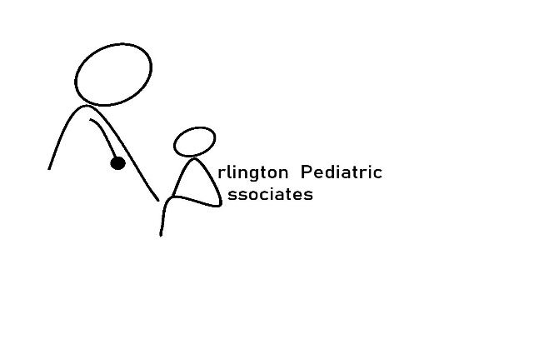
COVID-19 UPDATE: A LETTER FROM ARLINGTON PEDIATRIC ASSOCIATES
As most of you are aware our office staff was exposed to the Covid-19 virus. Out of an abundance of caution, and under the recommendation of the Department of Public Health, our staff was quarantined for 14 days. During this time our physicians and staff have been working closely with the DPH to determine the best course of action for our re-opening.

Starting Thursday March 26th our office will resume business operations. We want you to know that the health and safety of our patients and families is our top priority. For these reasons, we will be implementing the following measures in our office for the time being.

1. Walk in hours are canceled indefinitely.
2. All well appointments for patients ages over 2 will be postponed until June 2020.
3. Our office will operate with a "sick team" and a "well team". This may mean that you may not be able to see your primary care physician upon request.
4. We will be pre-screening all scheduled patients for illness. We also request that only 1 adult accompany patients to appointments and all siblings should remain at home.
5. Upon arrival to the office, we ask that all patients call first. Patients should remain in their car until instructed to enter the office. Our goal is to have no patients waiting in the waiting room.
6. At this time, testing for the Covid-19 virus is unavailable. We are currently screening all patients for coronavirus (COVID-19) by phone and all patients/families at the time of check in to minimize transmission of this illness among our patient population. Patients who screen positive over the phone will be advised to remain home while our staff works with the MA Department of Public Health to determine the next steps in their care.

We do understand that this a major inconvenience, but we do feel it is necessary to ensure the safety of our patients and staff, which is always our highest priority.

Sincerely,
Arlington Pediatric Associates

